Archdiocese of Miami  C/O Florida Catholic  9401 Biscayne Blvd  Miami, FL 33138  Phone (305) 762-1131  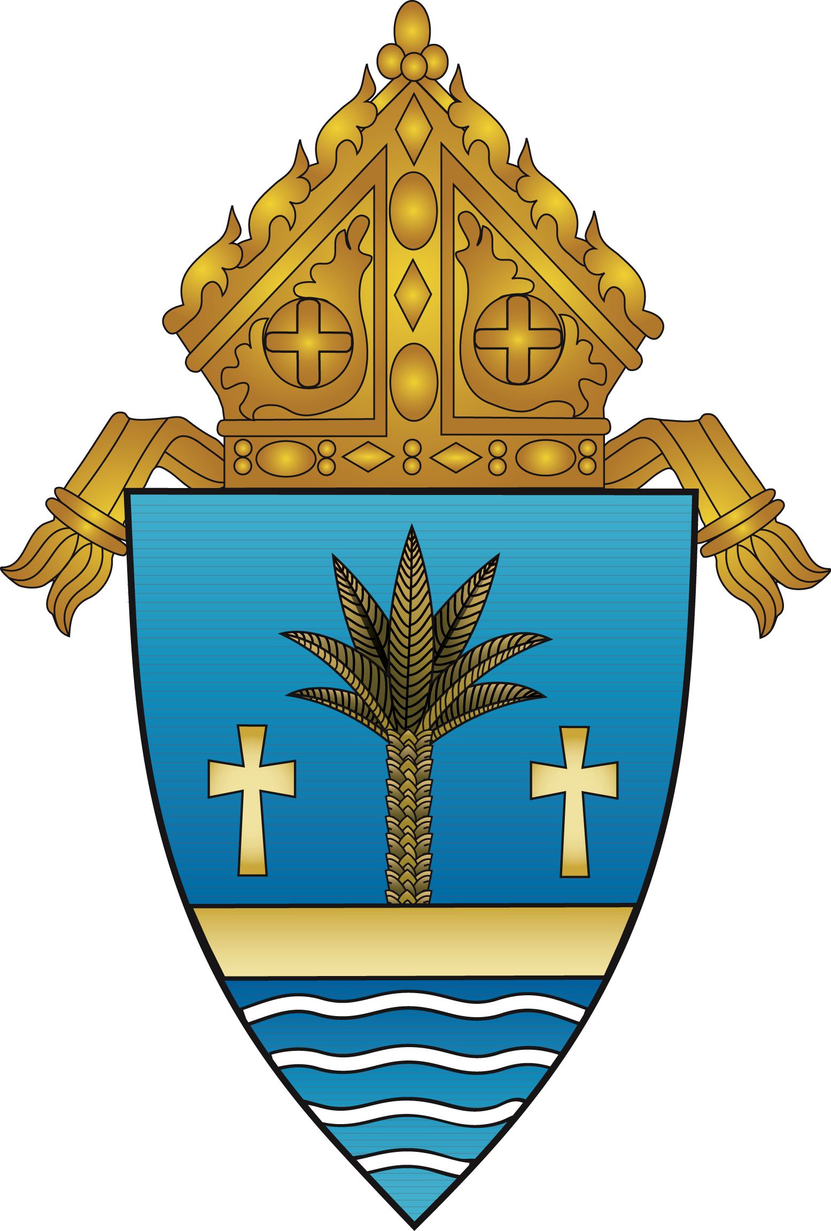  Fax (305) 762-1132 | ORDER FORM
 | Date: ________________________

Ordered by:  [Name] ___________________________________________  [Company Name] __________________________________  [Street Address]____________________________________  [City, ST ZIP Code]_________________________________  [Phone] ___________________________________________ | Deliver To: □ Same as ordered by  [Name] ___________________________________________  [Company Name] __________________________________  [Street Address]____________________________________  [City, ST ZIP Code]_________________________________  [Phone] ___________________________________________

* Book available in English, Spanish and Creole

DESCRIPTION | Quantity | Amount
History of the Archdiocese of Miami Book-  ENGLISH version |  | $35/ per book
History of the Archdiocese of Miami Book-
SPANISH version
History of the Archdiocese of Miami Book-
CREOLE version
 | Sub- total
 | Shipping & handling ($2.95 per book)
 | GRAND TOTAL

MAKE ALL CHECKS PAYABLE TO ARCHDIOCESE OF MIAMI; please do not send cash.
Payment is due with order form; send payment and order form to 9401 Biscayne Blvd Miami, FL 33138 C/O Florida Catholic
If you have any questions concerning this invoice, contact Ana Rodriguez- Soto
(305) 762-1131 or arsoto@theadom.org

Thank you for your business!
Internal Use Only
Ship Date:

